UIN: 1086

8/29/2024

COP 4610 – Operating Systems

**Assignment 1**

**1.) Install Ubuntu in Virtual Box**

1. *Provide Screenshot*

Figure A: Ubuntu 24.04

**2.) Practicing Basic Unix Commands**

1. *Create a new directory named simple_assignment in your home directory and navigate into it.*

* *Command: Create a directory and change*

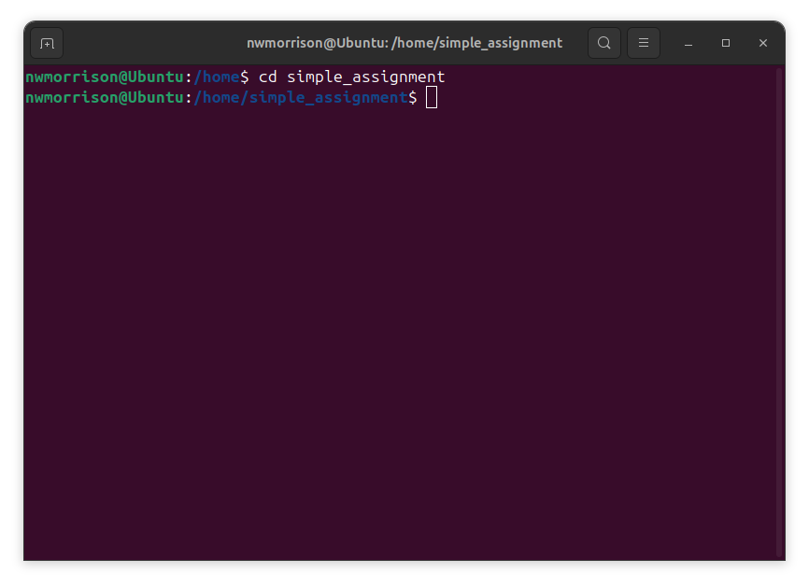

1. *Create a new file named example.txt and add the text "Unix is fun!" to it.*

* *Command: Create a file and redirect text output to it.*

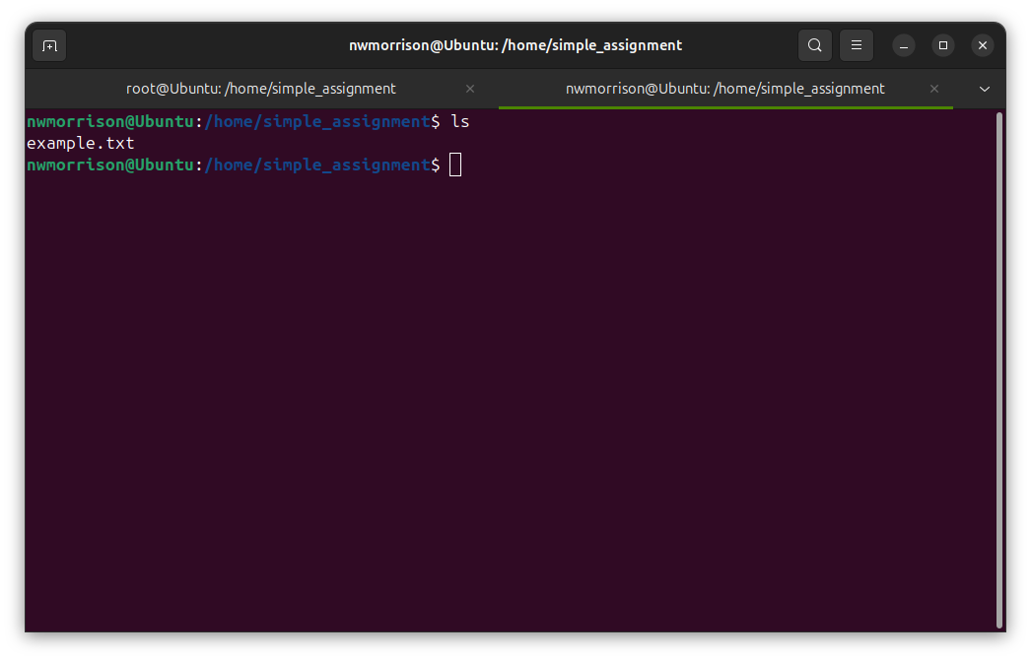

1. *Display the contents of example.txt.*

* *Command: Display the content of a file.*

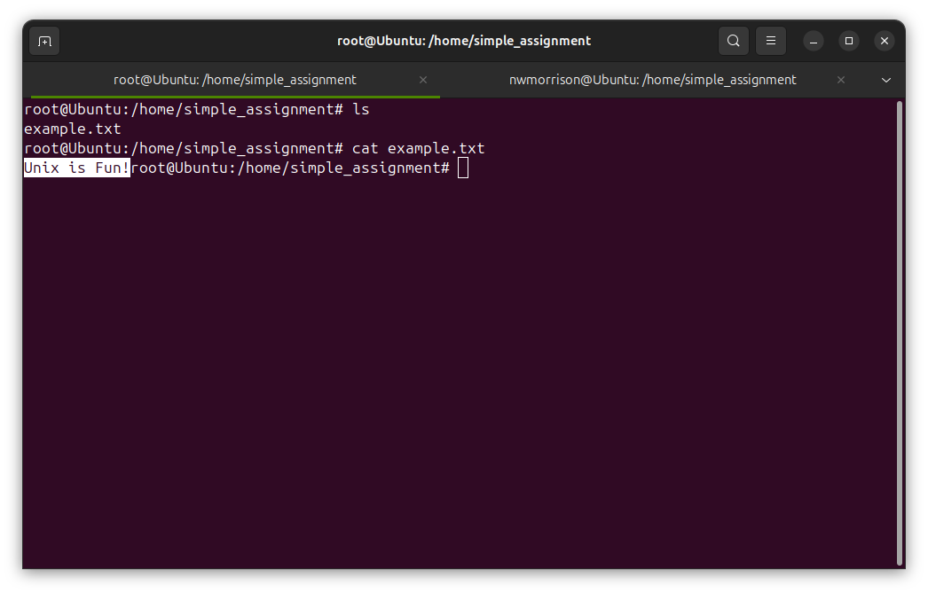

1. *Append the text "Learning is ongoing." to example.txt.*

* *Command: Append text to an existing file.*

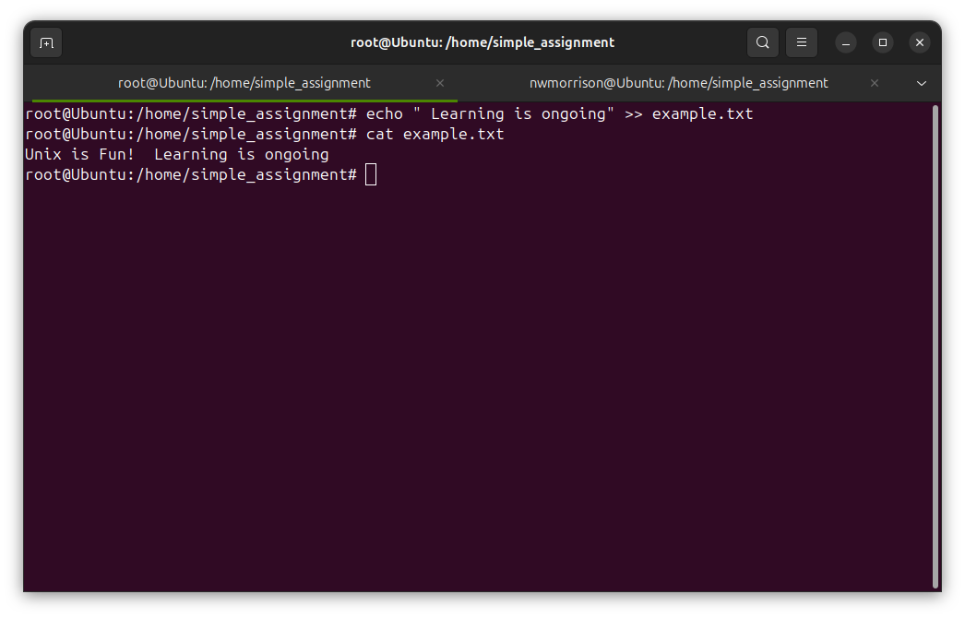

1. *Count the number of words in example.txt.*

* *Command: Count words in a file.*

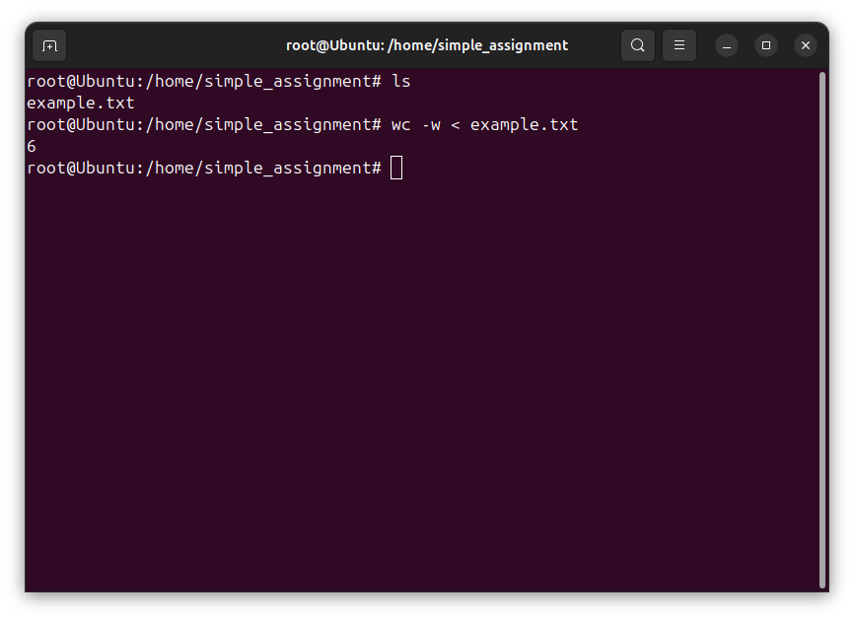

1. *Display the current date and time.*

* *Command: Display the current date and time.*

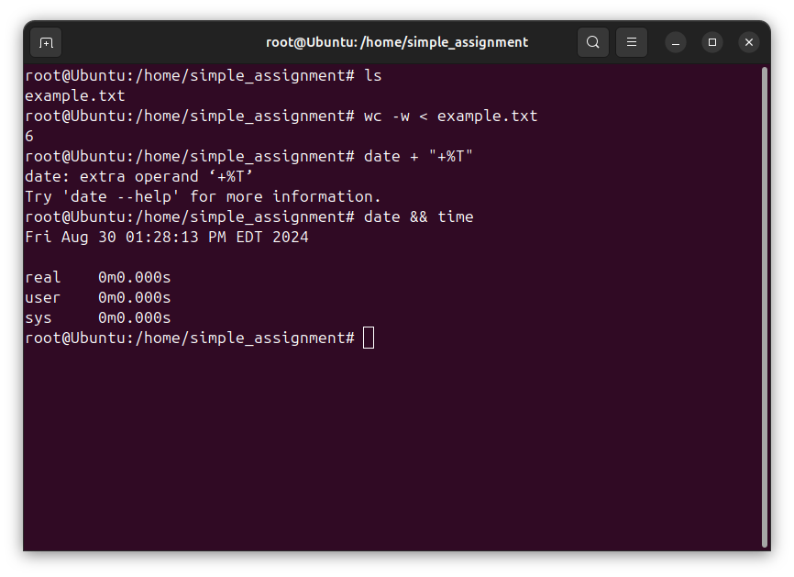

**3.) Linux Distribution Descriptions**

1. Ubuntu:

* Released biannually, with long-term support versions every two years, Ubuntu employs a widely used desktop environment. Its software repository and broad hardware compatibility make it a solidchoice for both personal and server use. The distribution's large and active community provides generous support for users of all levels.

1. Red Hat Enterprise Linux (RHEL):

* As a commercial distribution, RHEL targets enterprise environments with a focus on stability and long-term support. It offers subscription-based services, including complete technical support and professional certification programs. Many corporations rely on RHEL for their data centers and critical applications.

1. Kali Linux:

* Designed for cybersecurity professionals, Kali Linux comes pre-loaded with hundreds of tools for penetration testing and digital forensics. Kali's portability, allowing it to run from a USB drive, makes it a favored choice among security researchers and ethical hackers for on-the-go assessments.

1. Raspbian (Raspberry Pi OS):

* Optimized for a specific single-board computer, this distribution transforms low-cost hardware into versatile computing devices. Users can turn their small computers into desktop systems, media centers, or Internet of Things devices. The distribution primarily focuses on education and its affordability has made it popular in schools and do it yourself builds.

1. Linux Mint:

* Mint prioritizes stability and ease of use. It offers multiple desktop environments, including one developed by its own team. Mint is known for including proprietary media codecs by default, enhancing out-of-the-box multimedia support.